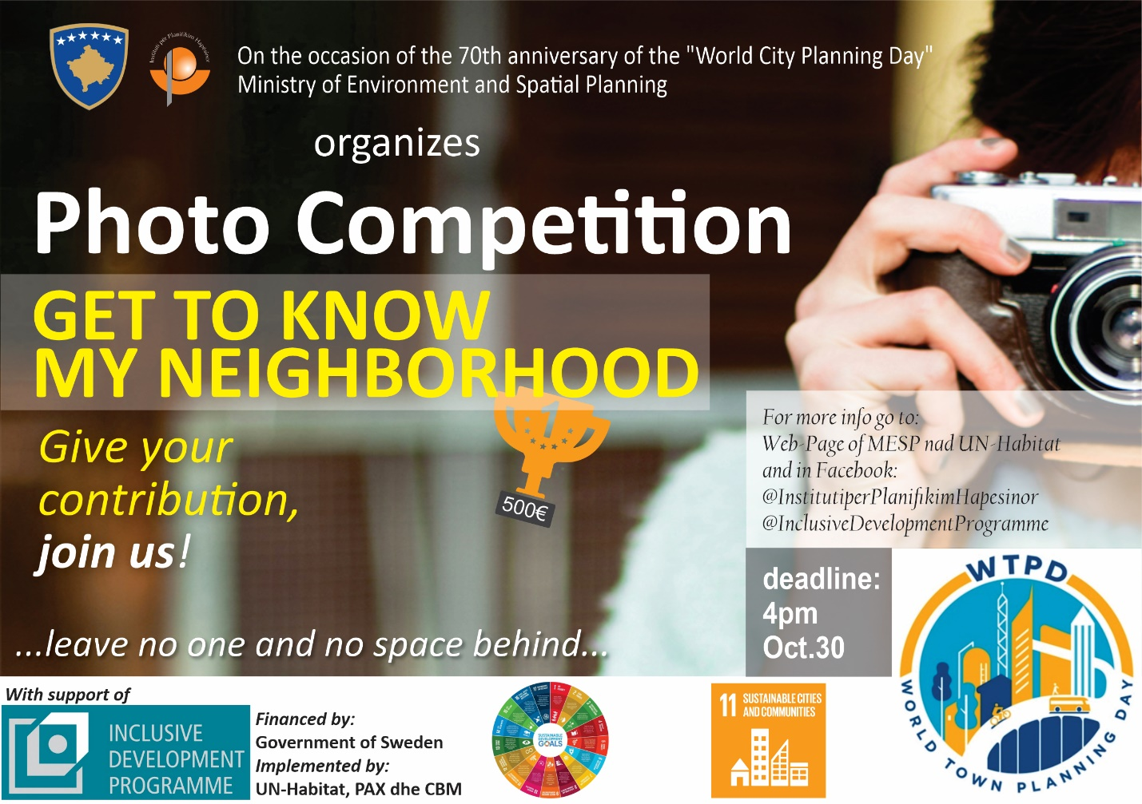

“GET TO KNOW MY NEIGHBORHOOD”
...leave no one and no space behind…

PHOTOGRAPHY COMPETITION

Terms of participation

- Background

This year marks the 70th anniversary of the “World Town Planning Day”. Established in 1949 by Professor Carlos Maria Della Paolera of the University of Buenos Aires, this day aims at stimulating the interest of both the professionals and the general public in urban planning. On this occasion, the Ministry of Environment and Spatial Planning / the Institute for Spatial Planning in partnership with the Inclusive Development Programme implemented by UN-Habitat, PAX, CBM, and financed by the Swedish Development Cooperation is organizing a photography contest.

The proposed topic for the competition is “Get to know my neighborhood – Leave no one and no space behind” – emphasizing on the neighborhood as a crucial element of future spatial development of our settlements.

The messages conveyed through the competing photographies should be an incentive for Kosovo decision-makers to take the necessary steps towards improving conditions at the neighborhood level, leaving no one and no space behind!

“Leave no one behind” lies at the heart of the Sustainable Development Goals (SDGs), which are a set of 17 goals adopted in 2015, to be achieved worldwide by 2030. Sound spatial planning is an essential element in reaching the Sustainable Development Goals. By crafting more inclusive, sustainable, resilient and safer urban and rural settlement, spatial planning has the potential to address numerous issues underpinning the SDGs such as environmental degradation, gender inequality, peace, health and well-being.

This photograph contest fits within this global effort of reflecting and acting upon major issues to build a more resilient, sustainable and inclusive Kosovo by 2030. Lifting up to this ambitious vision requires discussions and actions at every level from the global level, to the most local level like neighborhoods.

Participating photographies, respecting the requirements will be exhibited on the 8th of November in the lobby of the Ministries Building Rilindja. This exhibition will then be showcased in a number of municipalities as well as on the websites of the Ministry of Environment and Spatial Planning and UN-Habitat.

- SELECTION PROCESS

- Criteria of evaluation

- The photograph should be relevant to the theme of the contest. As such, the photograph should represent the impressions for the neighborhoods that are an integral part of our settlements.

- It may showcase positive or negative aspects.

- The photograph should highlight some of the issues addressed by the Sustainable Development Goals, particularly Goal 11 dealing with sustainable cities and communities, and Goal 13 on climate action. As such, the photograph could, for instance, underline the following themes:
- housing
- waste-management,
- water (rivers)
- environmental impact of the city and air quality,
- access to safe, affordable and sustainable transportation,
- access for all to green and public spaces with particular attention to women, children, elderly, and persons with disabilities
- Cultural and Natural Heritage
- urban culture (people, graffiti etc.)

- The picture should be of good quality and should have some artistic depth.

- Jury

The jury body will be composed of both professionals in urban planning and photography, which will judge the competing photos according to the above mentioned criteria.
- Prizes

Three prizes will be attributed for 1st, 2nd, and 3rd place by the jury. Authors of the winning photos will be informed in advance by email and invited to the prize-giving ceremony which will take place on the “World Town Planning Day”, the 8th of November 2019.
- 1st prize: 500 €
- 2nd prize: 200 €
- 3rd prize: 100 €

3. CRITERIA FOR APPLICATIONS

a. Who can apply?

The competition is open to all city and art lovers, amateurs and photography professionals.

b. Submission guidelines

- The photograph must be enclosed with the name and surname of the author of the photograph, a contact telephone number and the name of the location shown in the photograph.
- The photograph must be copyrighted.
- The picture should be:
  - in JPEG electronic form, with a minimum width of 600 px and a maximum size of 5MB.
  - in A3 format (standard paper quality).
- Each contestant must compete with 1 to 3 pictures at most.
- Contestants should specify in his/her e-mail if the image is taken by a digital camera or phone.
- Competing photos should be sent to the email iphotokonkursi19@gmail.com or to the MESP / ISP address (ex “Rilindja” building) floor XIV, office 1405, by the 30th of October, 2019, 16:00.

